**ABSTRACT**

The need for glucose biosensors increase annually as the rate of diabetes increases every year. In this study, we aim to test the sensitivity and specificity of the Sensi-GO™ technology to assess its feasibility as a glucose biosensor.

The study was conducted by comparing four patient urine samples with given symptoms through investigating the relationship between glucose concentration and green pigmentation.

The results from the clinical trial displayed that green pigmentation was linearly proportional to glucose concentration evidenced with positive and negative controls of glucose and sucrose standard solutions. Comparisons with commercial biosensors and sources of error is further discussed in this report.

**INTRODUCTION**

Nowadays, diabetes is one of serious problem that spread swiftly. According to WHO, the global prevalence of diabetes increased remarkably in 18 years from 1980 by 80.85%. As blood glucose concentration is the major diagnostic criterion for diabetes, the need of glucose biosensor were also rising to help patients monitor their glucose concentration (Yoo & Lee 2010). Enzymatic glucose biosensor is the main type of biosensor used due to its desirable high sensitivity and cheap cost (Wang & Lee 2015).

The first leading market type of biosensors is the non-invasive technology Multistix©. Multistix© uses the degree of colour change after the strip is inserted into solution, whereby chromogen, a chemical present in test strip will produce a specific colour or intensity change from the presence of glucose, that can then be visually aligned with a colour chart.

Blood glucose sensor is the second type of most widely used biosensor. The glucose concentration is displayed after an electrical signal, that is released from the glucose oxidation reaction, is read when the test strip is inserted into the meter.

Multiple flaws from these biosensors involve the inaccuracy in visual judgement, potentially unreliable results from failure of Multistix© strip insertion and the painful process of sample collection from the invasive blood glucose monitor. Thus, a new type of non-invasive glucose biosensor, Sensi-GO™ technology was researched, whereby the oxidation of glucose with added enzymes allows green pigment saturation to be evaluated. In this study, we aim to test the sensitivity and specificity of the Sensi-GO™ technology to assess its feasibility as a glucose biosensor

**MATERIALS**

The following materials were used in the clinical trial to create and test this Sensi-GO™ biosensor.

* 20 x 2ml test tubes.
* Pipettes
* Scissors
* Solution A (40 U/ml glucose oxidase (GO), 25 U/ml horseradish peroxidase (HP) and buffer).
* Solution B (0.1 mg/ml AB-TS in water)
* Sucrose Standard Solutions (10 and 20 mM)
* Glucose Standard Solutions (0, 10, 15 , 20 and 25 mM)
* ColorGrab app
* 4 x Multistix©® diagnostic test strips
* Patient urine samples:

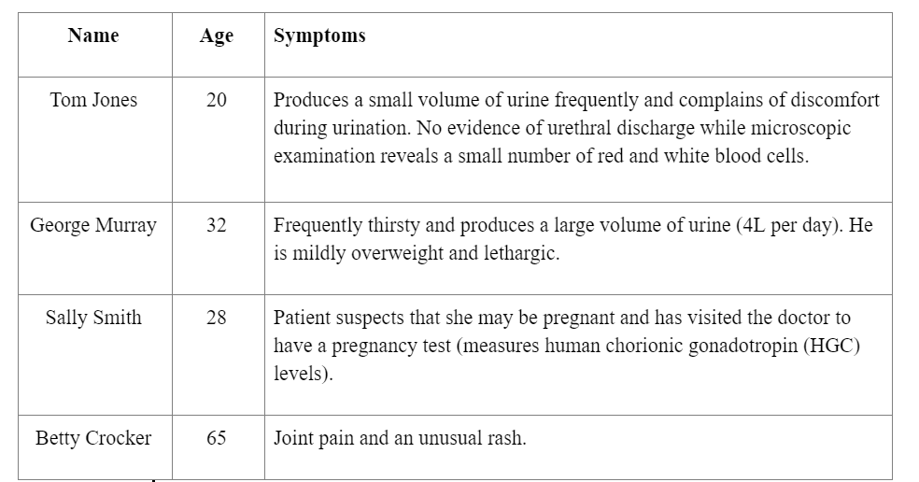

**METHOD**

1. Pipette two drops of solution A onto a strip, followed by two drops of solution B.

This procedure is a patented technology known as Sensi-GO™™, which is a novel formulation of optimizing the work of the enzyme glucose oxidase when it is bound to different materials and on various biological fluids. It is expected to detect the presence of glucose via two chemical reactions. Glucose is first converted to gluconic acid and hydrogen peroxide by reacting with the enzyme, glucose oxidase. Then by reacting horseradish peroxidase, hydrogen peroxide is then converted to water and AB-TS (a free radical oxygen species that oxidises a colourless solution to a dark green compound AB-TSG (Whitelock et al. 2018).

1. Repeat Step 1 for each glucose and sucrose standard solutions.
2. Repeat Step 1 with each patient’s urine sample three times.
3. Measure the solution colour pigmentations by the ColourGrab app, providing RGB values that could be used to calculate colour saturation percentage, after 90 seconds.
4. Plot the data linearly to see the relationship between pigment saturation and glucose concentration.
5. Compare results from Sensi-GO™ with Multistix©® diagnostic test strips and the blood glucose monitor reading.

**Results**

Sensi-GO™ Technology

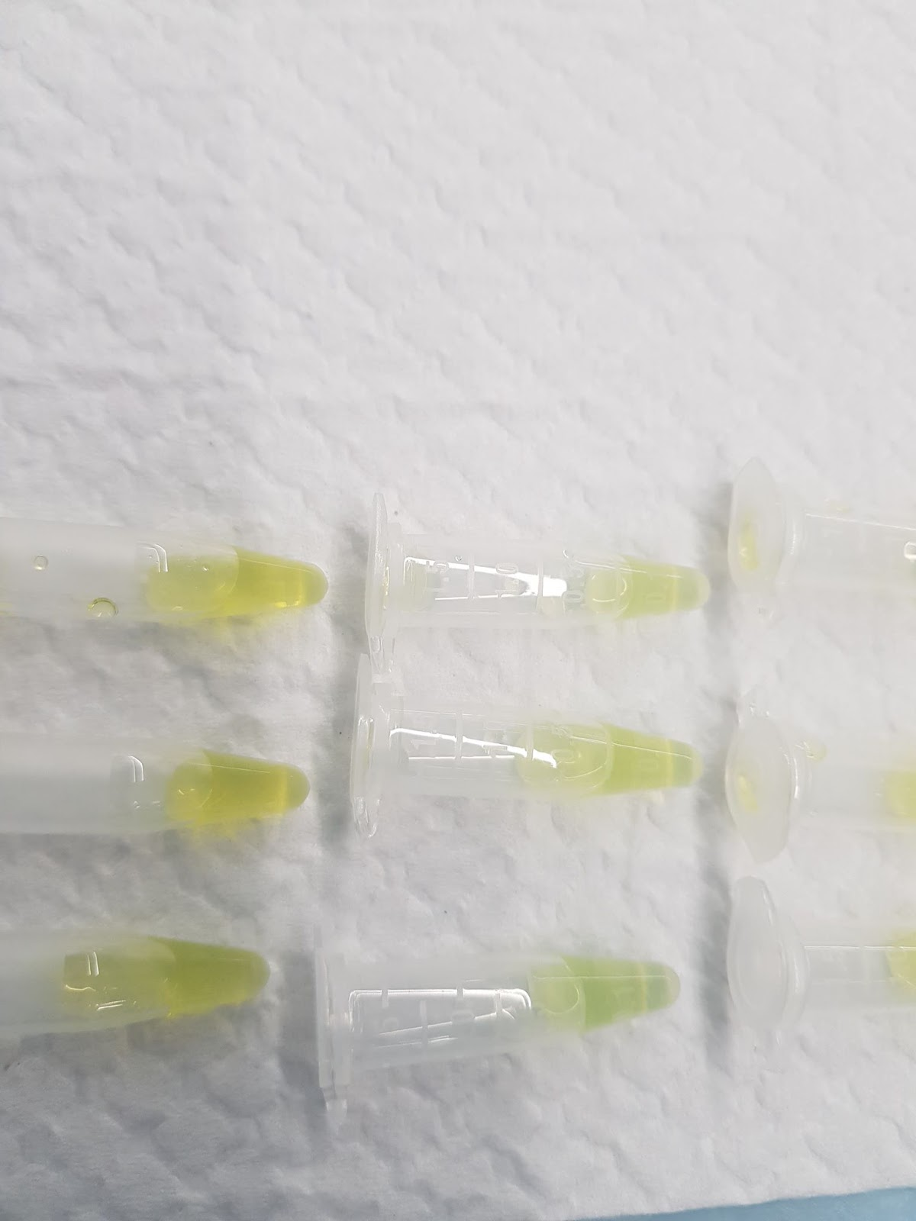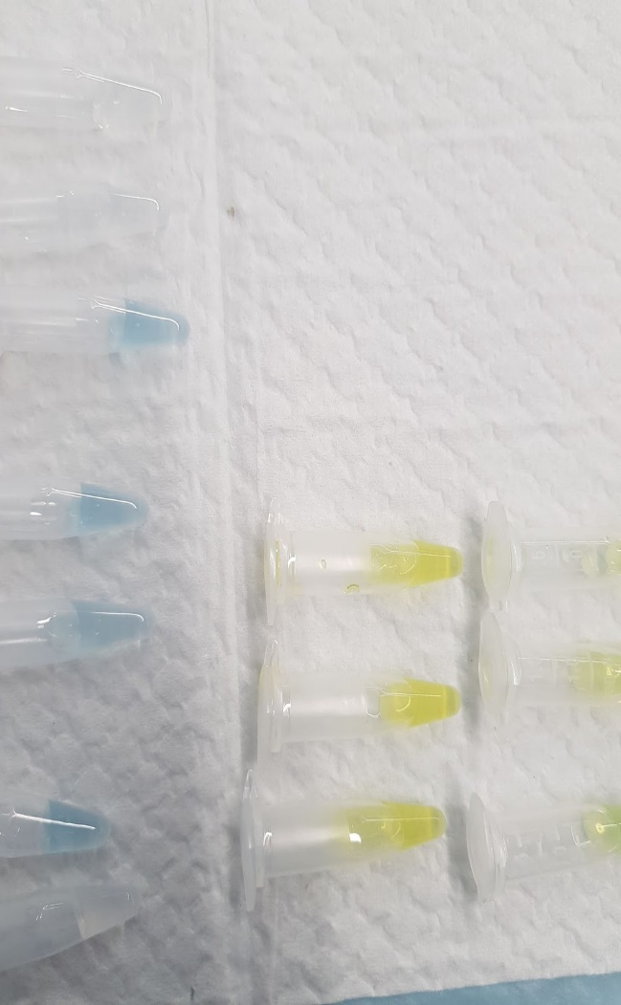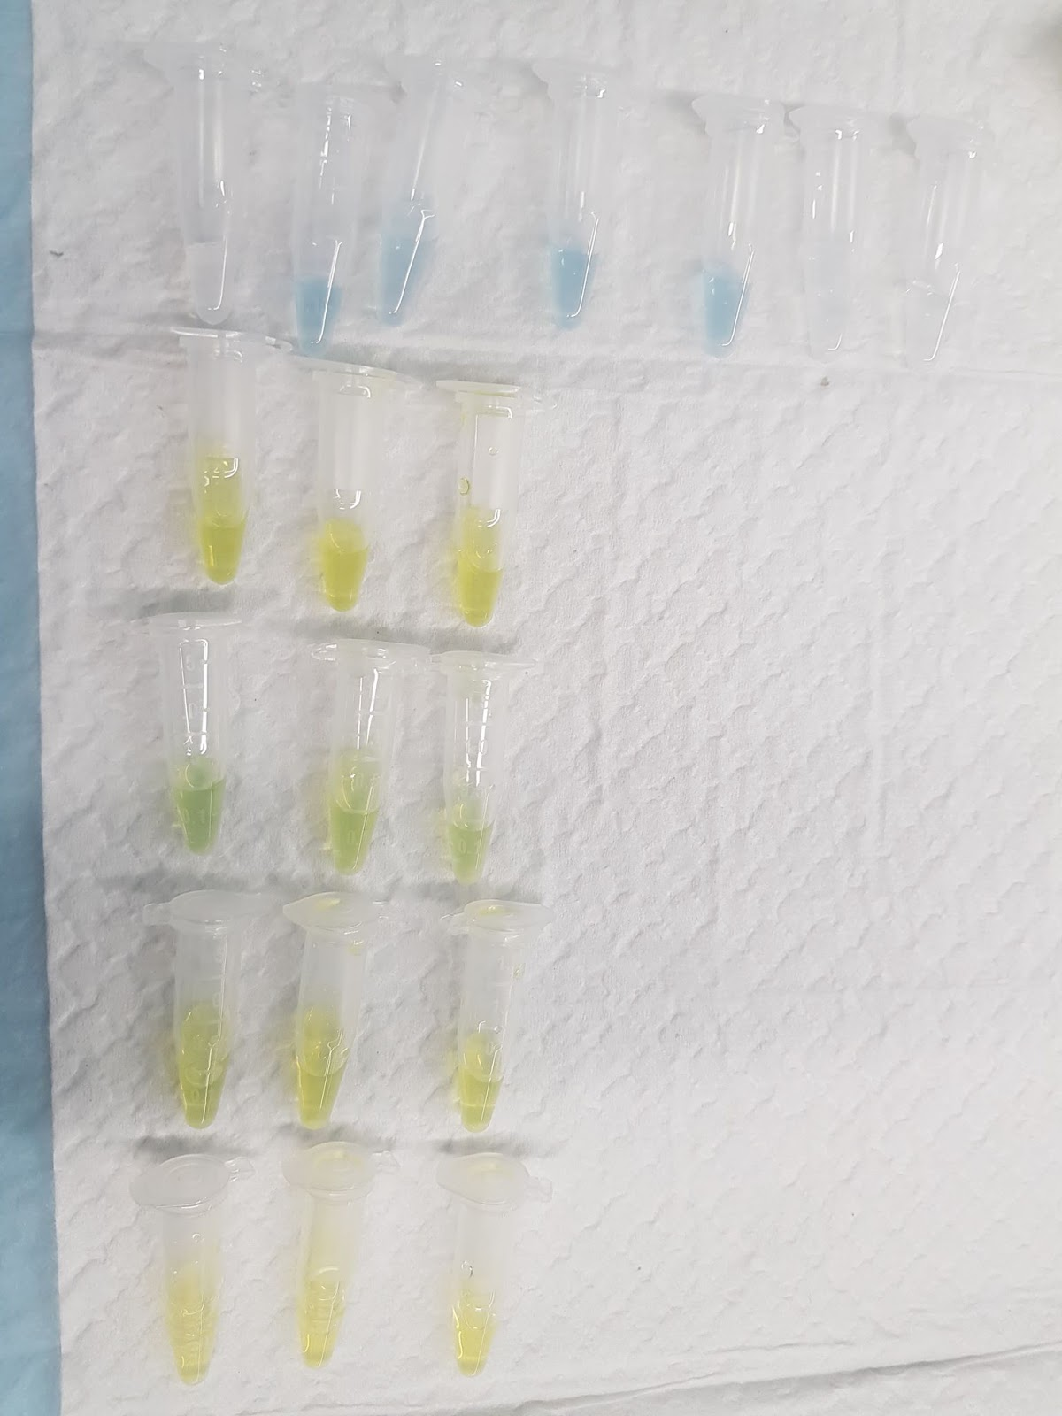

Figure 3: George Murray's sample

Figure 2: Tom Jones' sample

Figure 1: Glucose (0,10,20,25 mM) and Sucrose (10,20 mM) Standard Solutions

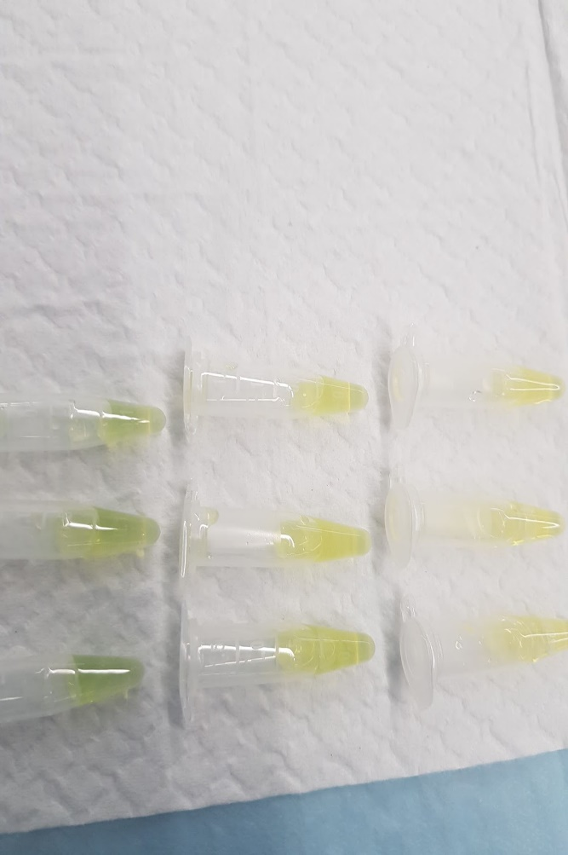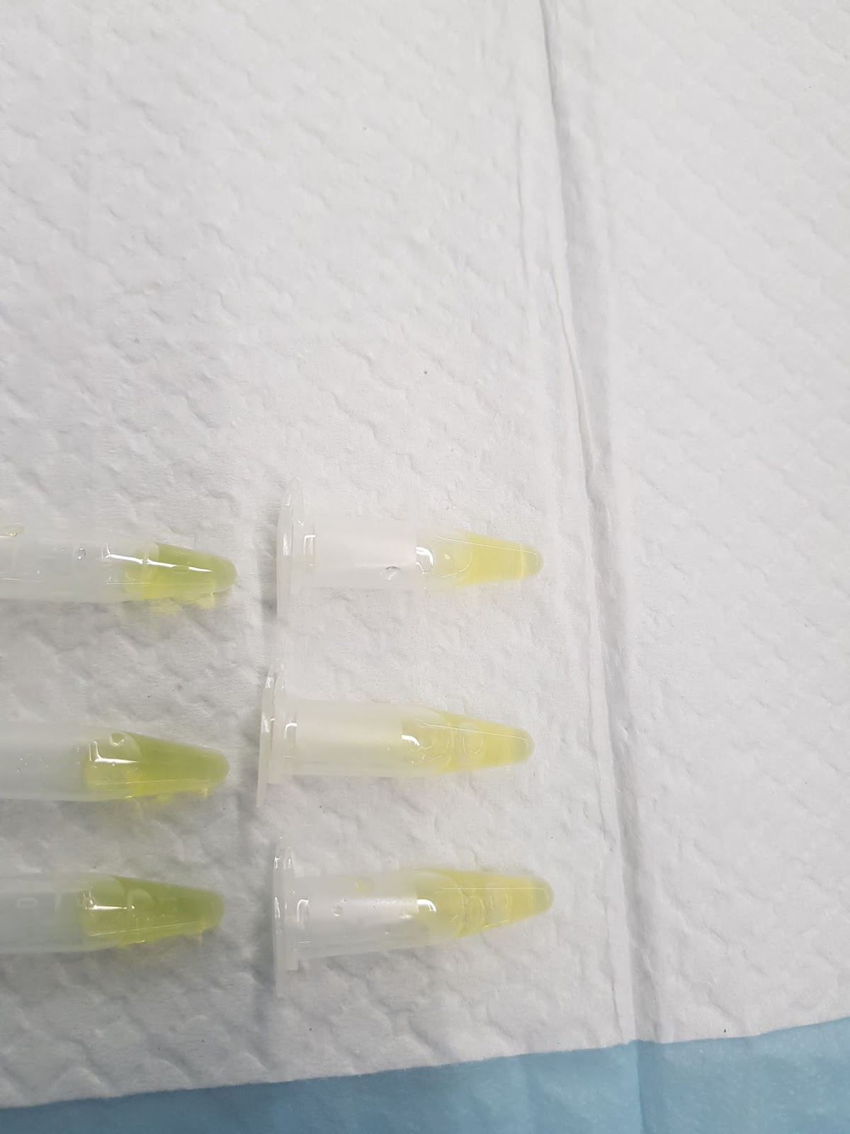

Figure 4: Sally Smith's sample

Figure 5: Betty Crocker's sample

Table 1:Green Pigment % for Glucose Solutions

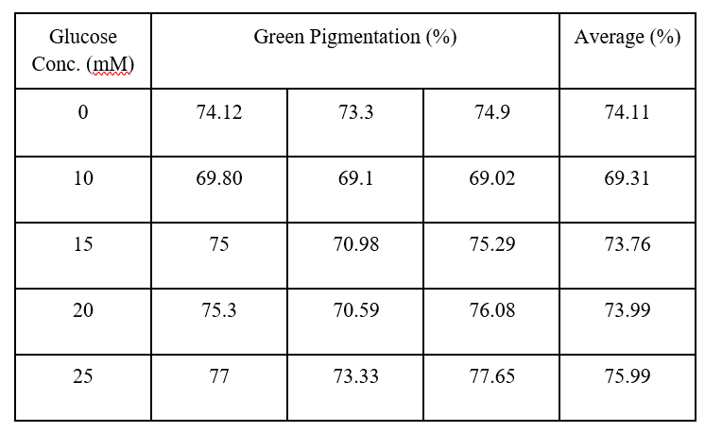

Table 2: Green Pigment % for Sucrose Solutions

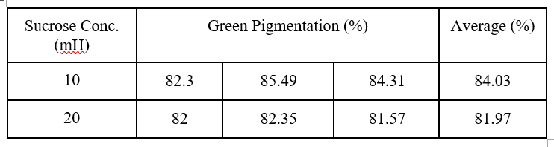

From Table 1, there is an evident increasing trend in green pigmentation as glucose concentration increases. There is an outlier of the first 0 mH glucose standard solution as the green pigmentation is expected to be close to 0. However, the green output of the RGB value obtained from the colour analytics app ColourGrab was exponentially higher than expected due to the image of the test strips being warped from shadowing and the hue from the white background. This darkened the colour to a deep grey which contained a high green output value. However visually, there was no green pigment in the clear solution.

The following graph indicates a linear relationship between the glucose concentration and green pigmentation.

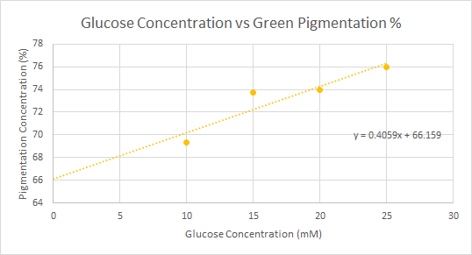

Figure 6: Glucose Conc. vs Pigment % Linear Plot

From the line of best fit, the patient glucose samples were calculated by rearranging the linear equation:

Table 3: Patient Glucose Concentrations

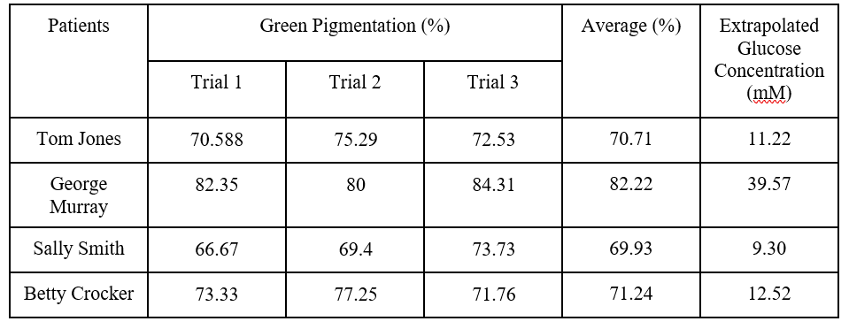

Multistix©

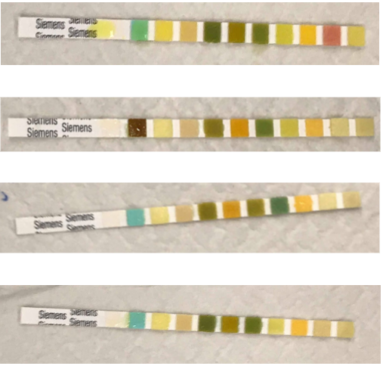

*Figure 10: Betty Crocker’s Multistix© strip*

*Figure 8: George Murray’s Multistix© strip*

*Figure 7: Tom Jones’ Multistix© strip*

*Figure 9: Sally Smith’s Multistix© strip*

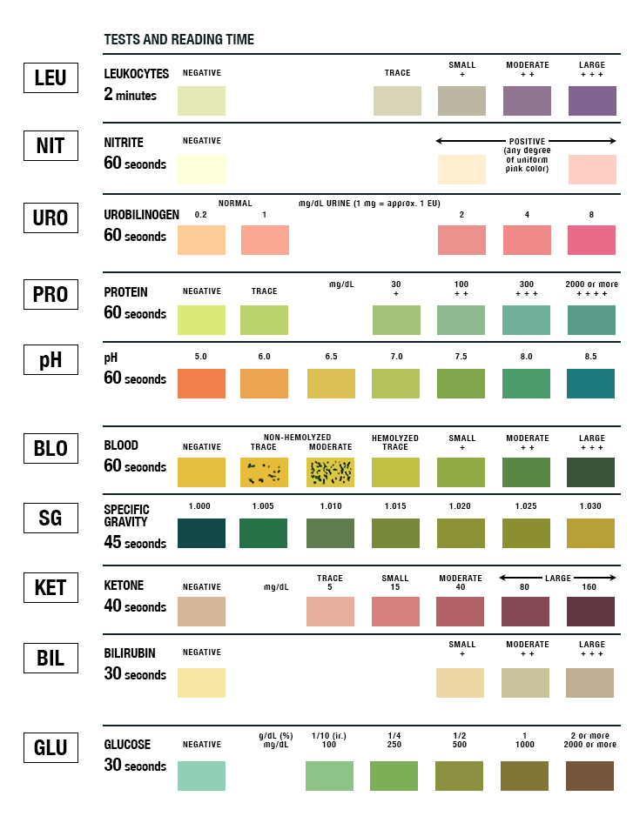

Figure 11: Multistix© Colour Chart

From the last row on Figure 11, the colour scale given for glucose composition in the sample is used as a reference to compare the patient strips. Observing the second box that indicates glucose presence, George Murray’s strip displays a deep brown shade, suggesting a glucose concentration of ≥111 mM/L, whilst the other three patients largely show a negative presence of glucose.

The reading from the commercial blood glucose monitor indicated a reading of 25.9mM/L.

From the trendline, the glucose concentration in all urine samples were calculated from the obtained green pigmentation percentage outputs off ColorGrab. From Table 3, it is observed that George Murray’s glucose concentration was significantly higher than the other 3 patients, indicating diabetes as a potential illness, with further consideration of his shown symptoms. This is further supported by the results obtained from the blood glucose monitor and Multistix© test strip.

**DISCUSSION**

Sensitivity and specificity

The ‘Sensi-GO’ technology is a measure of glycosuria (when blood glucose is passed into urine). However, there is an assumption made that the resulting blood glucose found in the urine is due to diabetes. Although the major cause of glycosuria is diabetes, there are other factors including renal glycosuria, alimentary glycosuria and Fanconi syndrome which results in elevated blood glucose in urine without necessarily indicating the presence of diabetes. However, this ‘Sensi-GO™’ technology still maintains a high sensitivity as the chances of having alternate health issues other than diabetes that cause the presence of glucose in urine is extremely low. However, ‘Sensi-GO™’ is more specific than other modern biosensors, in that it directly measures blood glucose, rather than resultant sugars in the system due to external factors such as medication. However, the experiment shows the slight presence of glucose in more than one sample (false negative).

Comparison to current commercial devices

Currently, commercially available glucose biosensors can be classified as point-of-care devices, continuous glucose monitoring systems and non-invasive glucose monitoring systems. Through the history of the development of glucose biosensors, the ongoing challenges of accuracy and reliability has always remained relevant. Electrochemical biosensors are the most common as they have better sensitivity, reproducibility and have a low-cost easy maintenance. However, many of the glucose biosensors today have inaccuracies as they also detect other sugars present such as maltose and xylose which are commonly found in drug formulation.

Effect of heat and oxygen levels on the Sensi-GO™ results.

With increasing temperatures, the rate of reaction will increase until it’s optimal temperature (30°C, as seen from Figure 12), from which it will then begin to denature the enzymes. In the tutorial room with a temperature of 20°C, optimal results could not be achieved.

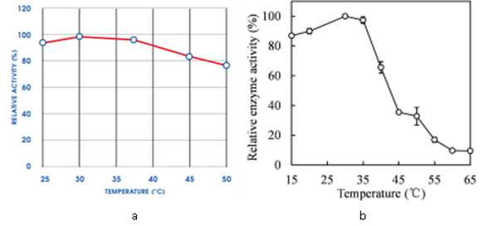

Figure 12: Optimal Working Temperature. a) Glucose Oxidase. b) Horseradish Peroxidase

Source: “Enzyme Glucose Oxidase”, “Enzyme properties and thermal stability of horseradish peroxidase”

Furthermore, if oxygen levels are low in the urine sample, this may result in oxygen being the limiting reagent which can lead to insufficient reaction of glucose molecules. This could have warped the production of hydrogen peroxide and thus reduce the green pigmentation displayed in the sample.

Sources of false negatives.

There were false positive results most likely due to contamination by substances such as hydrogen peroxide. Additionally, the contamination could also lead to false negatives by reacting with the glucose to form other products (hence lowering glucose levels)

Did Sensi-GO™ test pass the clinical trial? Why/Why not?

In the analysis of the results, the standard curve had to be adjusted in 0mM glucose concentration leading to inaccuracies. There was an indication of glucose in all the samples (false positive) in addition to the high error range (53%). Hence, it can be concluded that the Sensi-GO™ did not pass the clinical trial.

Limitations

The Sensi-GO™ biosensor is dependent on the temperature (increase in reaction rate and denaturing of enzymes) and oxygen level (more reactant results in faster reaction rate). Extracting data from the colour of the resultant product is difficult as the colour is not dynamic results can be subjective.

Suggested improvements for your glucose biosensor.

* Maintaining a constant 30°C ambient environment (optimal temperature for both enzymes) using an automatic temperature regulator
* More repetition for each same as the colour is dynamic, the error range of the average green pigmentation is lowered

**CONCLUSION**

Sensi-GO™ glucose biosensor response revealed a higher glucose concentration in George Murray urine sample who, according to the symptoms, might have Diabetes as a potential disease. However, it is important to notice that the biosensor also exposed glucose concentration in the remaining samples, which may indicate false positive results. For this reason, we conclude that the sensor does not pass the clinical trial since its reliability and accuracy are questioned.

**REFERENCES**

WHO 2018, *Diabetes*, Geneva, viewed 20 October 2018, <<http://www.who.int/news-room/fact-sheets/detail/diabetes>>.

Yoo, E. & Lee, S. 2010, ‘Glucose Biosensors: An Overview of Use in Clinical Practice’, *Sensors (Basel)*, vol.10, no.5, pp. 4558-4576.

Grand View Research, 2016, *Glucose Biosensor Market Size & Forecast Report 2012 - 2022*, California, viewed 20 October 2018, <<https://www.millioninsights.com/industry-reports/glucose-biosensor-market?utm_source=referral&utm_medium=paid&utm_campaign=prn_may3_glucosebiosensor_rd1>>.

Wang, H. & Lee, R. 2015. ‘Recent Developments in Blood Glucose Sensors’, *Journal of Food and Drug Analysis*, vol. 23, no. 2, pp. 191-200.

PR News Wire, 2016, *Test Strip Global Market by Application, Type, End Users - Volume & Value Forecast to 2021*, Pune, viewed 20 October 2018,

<[https://www.bizjournals.com/prnewswire/press_releases/2016/02/11/MN20668>.](https://www.bizjournals.com/prnewswire/press_releases/2016/02/11/MN20668)

Fletcher, M., Behrend, E., Welles, E., Lee, H. & Hosgood, G. 2011, ‘Glucose Detection and Concentration Estimation in Feline Urine Samples with the Bayer Multistix© and Purina Glucotest’, *Journal of Feline Medicine and Surgery*, vol.13, pp. 705-711.

Allied Market Research, 2018, *Self-Monitoring Blood Glucose Devices Market*, Oregon, viewed 20 October 2018, <<https://www.prnewswire.com/news-releases/self-monitoring-blood-glucose-devices-market-to-reach-10-82-bn-by-2025-at-4-2-cagr-says-allied-market-research-838754250.html>>.

*Multistix© Colour Chart*, accessed 20 October 2018

<https://learn.parallax.com/support/reference/urinalysis-test-strip-color-chart>

Fung, L., Yee, L. & Fei, M., 2015, ‘Development of an Amperometric -Based Glucose Biosensor to Measure the Glucose content of Fruit’,  *PloS One,* vol. 10, no. 3.

Halder, N. & Paul, D., 2015, ‘Effects of Oxygen Concentration on Glucose Sensor Response’, *ECS,* vol. 01, no. 42.

Baumstark, A., Schmid, C., Pleus, S., Haug, C. & Freckmann, G., 2013, ‘Influence of Partial Pressure of Oxygen in Blood samples on Measurements Performance in Glucose-Oxidase-Based Systems for Self-Monitoring of Blood Glucose’ , *Journal of Diabetes Science and Technology,* vol. 7, no. 6, pp. 1513-1521.

Wang, T., Tian, J., Li, T. & Zhang, L., 2016, ‘Enzyme properties and thermal stability of horseradish peroxidase (HRP-DL)’, *Journal of International Conference on Engineering and Technology Innovations,* pp.227-231.

Glucose Oxidase HPS300 2017, *ENZYMES,* Cat. GLOX-70-6456, UK.

Whitelock, J., Tang, F., & Liang, K., 2018, ‘BIOM 9420 Clinical Laboratory Science Clinical Trial Workshop 2 Background’. Paper presented at the moodle, University of New South Wales.